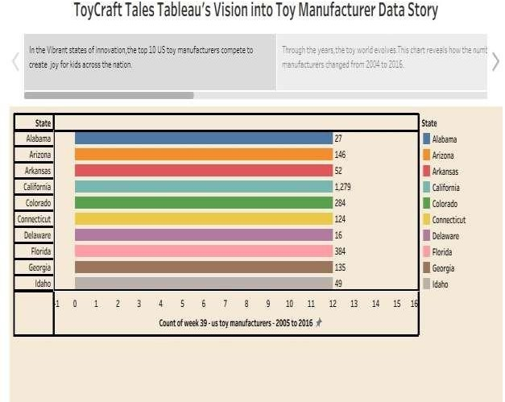

Link:

https://public.tableau.com/app/profile/kommini.sandeep.ratna.kum ar/viz/ToyCraftTalesStory_17511729646790/Story2?publish=yes